1. **The simulation results in Fig.3 are follows.**

In the simulation, I construct a signal:. The amplitude of the signal is a Guass function expressed as



and the phase of the signal is

σ

in the formula is equal to 300. The distribution of  is symmetric with a central wavenumber =0.7634??. is shown in Fig.1(a). In this case, (is a dispersion phase caused by two sides of unequal length in a cubic beam splitter). The IFT(Inverse Fourier Transform) of is shown in Fig.1(b).

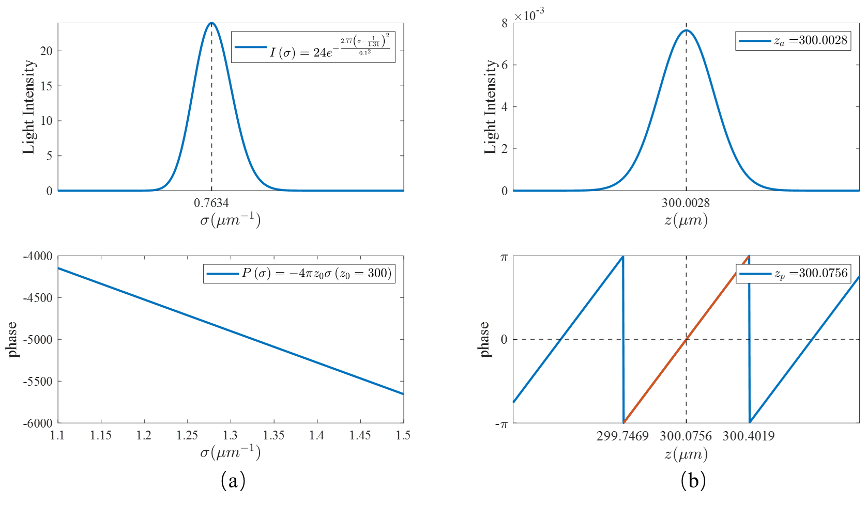

Fig. 1 (a)Amplitude() and phase() of . (b)IFT(Inverse Fourier Transform) of .

Then, IFT of  is expressed as



The peak position in the amplitude distribution of  is , and the zero phase position nearest is??.The period of the unwrapped phase distribution is T=0.655.To summarize, in the case of ,,.Thein the simulation is 1310nm.

**(2) The simulation results in Fig.4 are follows.**

In the simulation, The amplitude of the signal is a Guass function with noise and it can be expressed as



The noise ?? is belong to guass normal distribution and the  is expressed as



So, the distribution of  is asymmetric with a weighted average wavenumber =0.7634 ??. Phase of the signal does not change. Since, is expressed as



Amplitude and phase of the signal is shown in Fig.2(a). As well, the in the case is equal to 0. IFT(Inverse Fourier Transform) of the signal is shown in Fig.2(b).

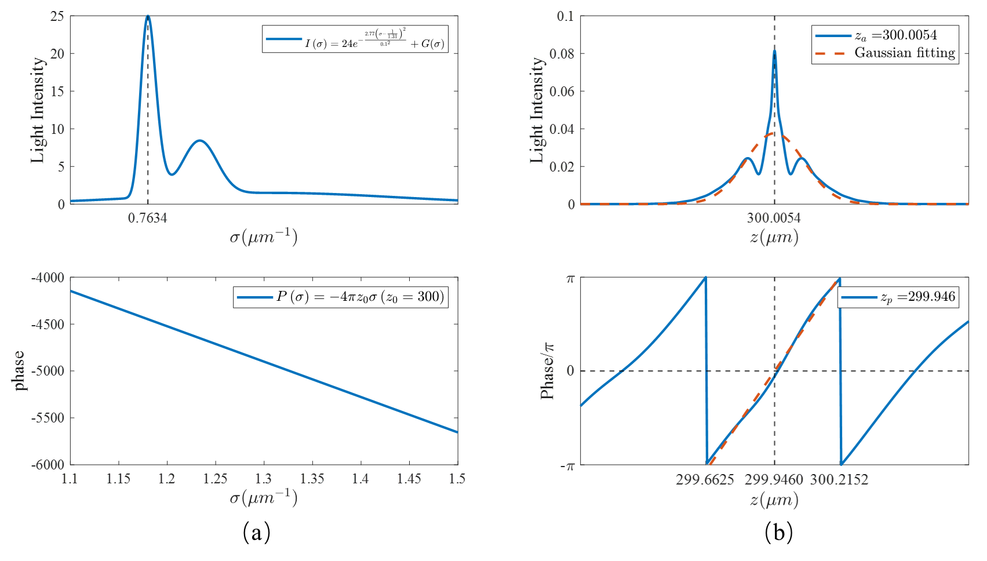

Fig. 2 (a)Amplitude() and phase() of. (b)IFT(Inverse Fourier Transform) of .

The peak position in the amplitude distribution of  is , and the zero phase position nearest is zP=299.946 ??.The period of the unwrapped phase distribution is T=0.5528.Hence, ,(Thein the simulation is ~~1310 nm~~ 763.4 nm). To summarize, in the case of , A(z) have a maximum value at and when P(σ)=-4πzoσ or P(σ) has only a linear component, but the phase distribution changes from the previous linear distribution to a nonlinear distribution because I(σ) is asymmetry.

[It is not good to describe only the results in the simulation. It is important to think theoretically and describe the reason why you get the results in the simulation.]

**(3) The simulation results in Fig.5 are follows.**

[It is important to think or consider what the purpose of the simulation. In Fig.5, the purpose is to examine the case that P(σ) contains nonlinear component. ]

In the simulation，phase of the signal has changed and the phase can be expressed as



 is a dispersion phase. The dispersion phase  is produced by an optical medium with refractive indexand thickness T,  is given by

~~~~ 

Since, is expressed as



If the parameterin is equal to 0 and T=1, then

  (10)

(1) Whenis equal to 10 andis equal to 0. Amplitude and phase of the signal is shown in Fig.3(a). IFT(Inverse Fourier Transform) of the signal is shown in Fig.3(b).

[In the below simulation, the results are similar as those in Fig.4 because b2 is a small value and P(σ)≅-4πzoσ or P(σ) has almost only a linear component. So, b2 (correctly b1) must have a larger value. ]

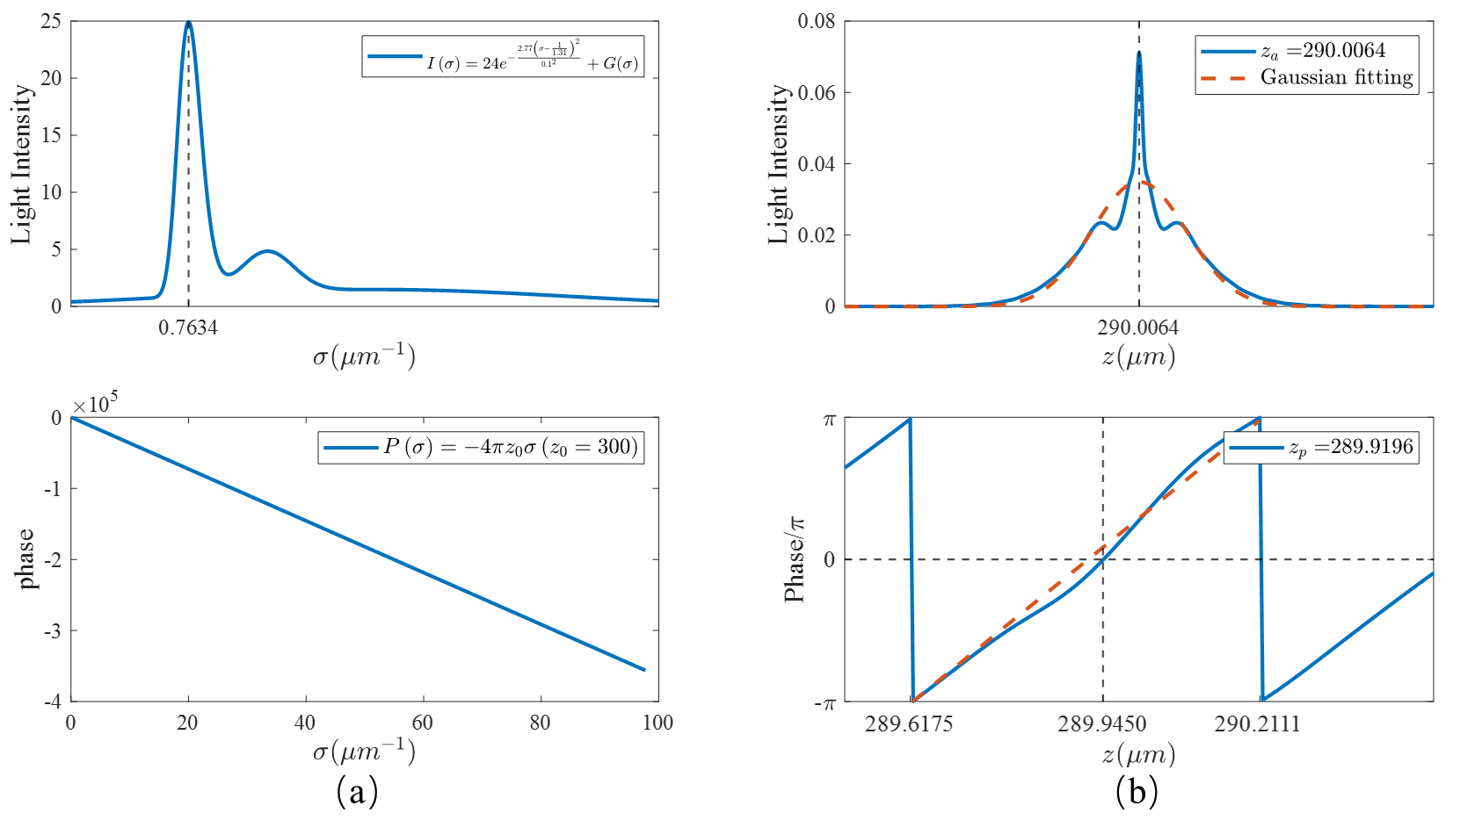

Fig. 3 (a)Amplitude() and phase() of . (b)IFT(Inverse Fourier Transform) of .

(2) Whenis equal to -1 andandis equal to 0. Amplitude and phase of the signal is shown in Fig.4(a). IFT(Inverse Fourier Transform) of the signal is shown in Fig.4(b).

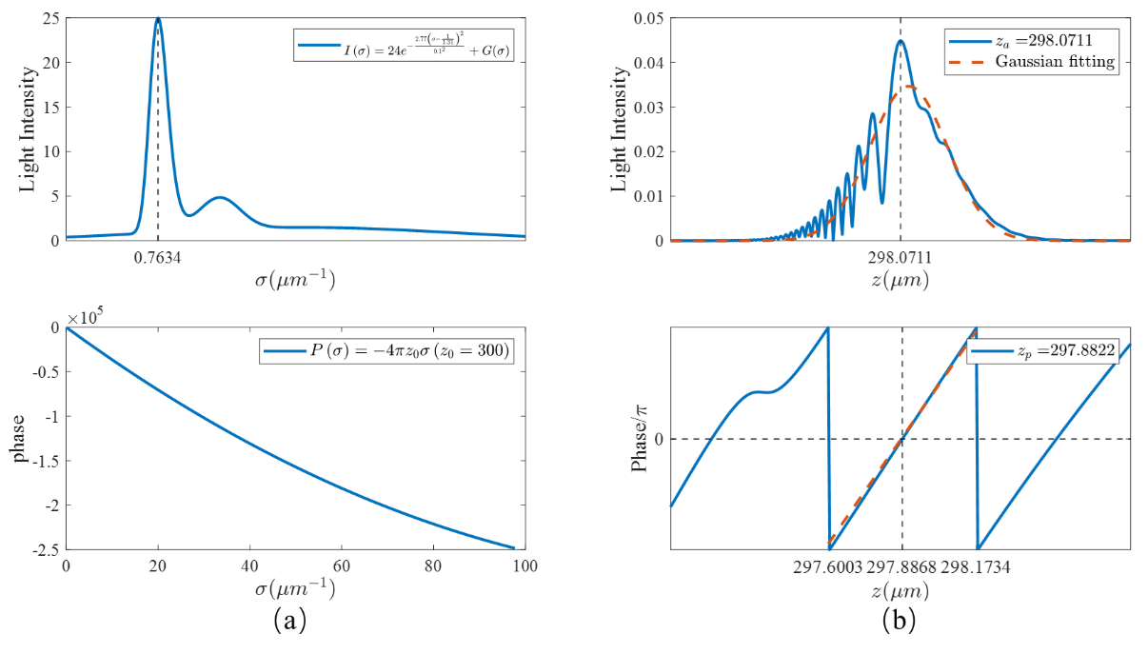

Fig. 4 (a)Amplitude() and phase() of. (b)IFT(Inverse Fourier Transform) of.

By calculating the offsets of different for the horizontal coordinates of the maxima , we find that the offset of the horizontal coordinate of the maximumis linearly related to  (-4πb2σ2).The relation ofandis shown in fig.5.

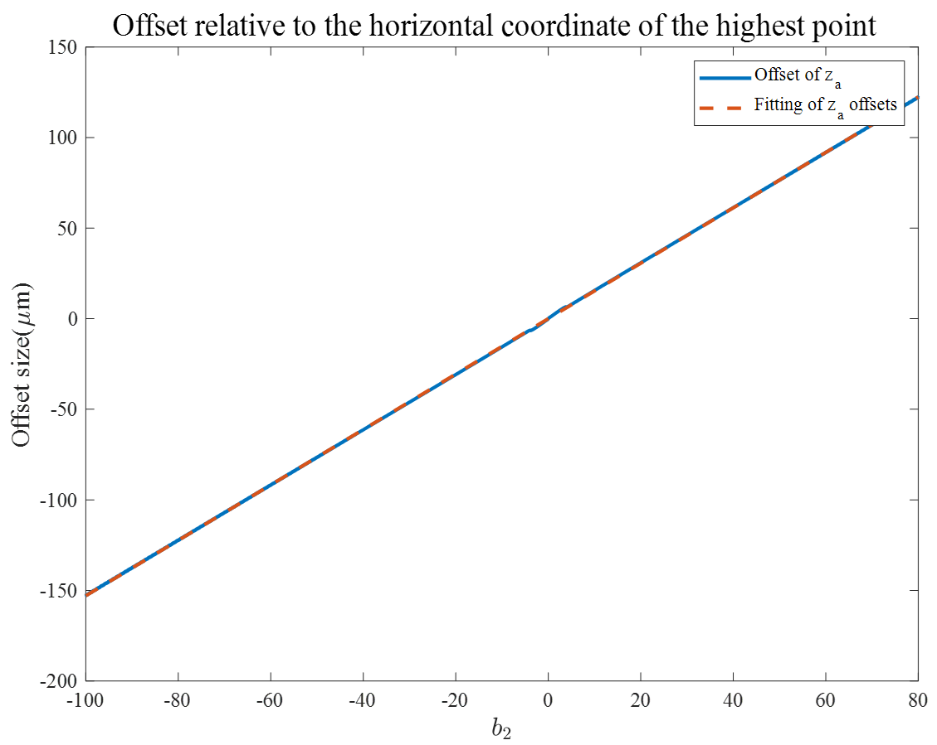

Fig. 5 Offset relative to the horizontal coordinate of the highest point.

The expression after linear fitting is



(3) If  and, then



Amplitude and phase of the signal is shown in Fig.6(a). IFT(Inverse Fourier Transform) of the signal is shown in Fig.6(b).

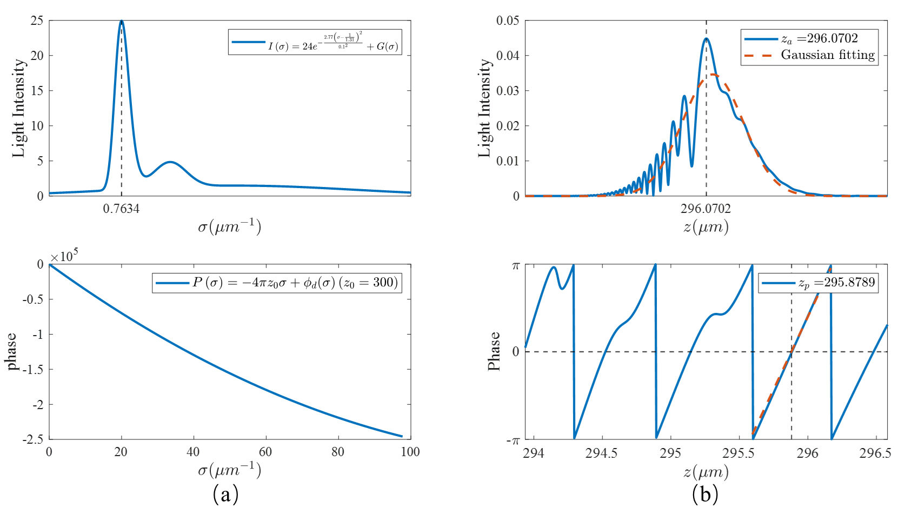

Fig. 6 (a)Amplitude() and phase() of. (b)IFT(Inverse Fourier Transform) of  when ϕd(σ)=-4π(-2σ- σ2).

From the Fig.6(b), The peak position in the amplitude distribution of is, and the zero phase position nearest is. From equation 11, we can get

??

The period of the unwrapped phase distribution is T=0.594. Hence, ,(Thein the simulation is 1310 nm??).

(4) If and, then



Amplitude and phase of the signal is shown in Fig.7(a). IFT(Inverse Fourier Transform) of the signal is shown in Fig.7(b).

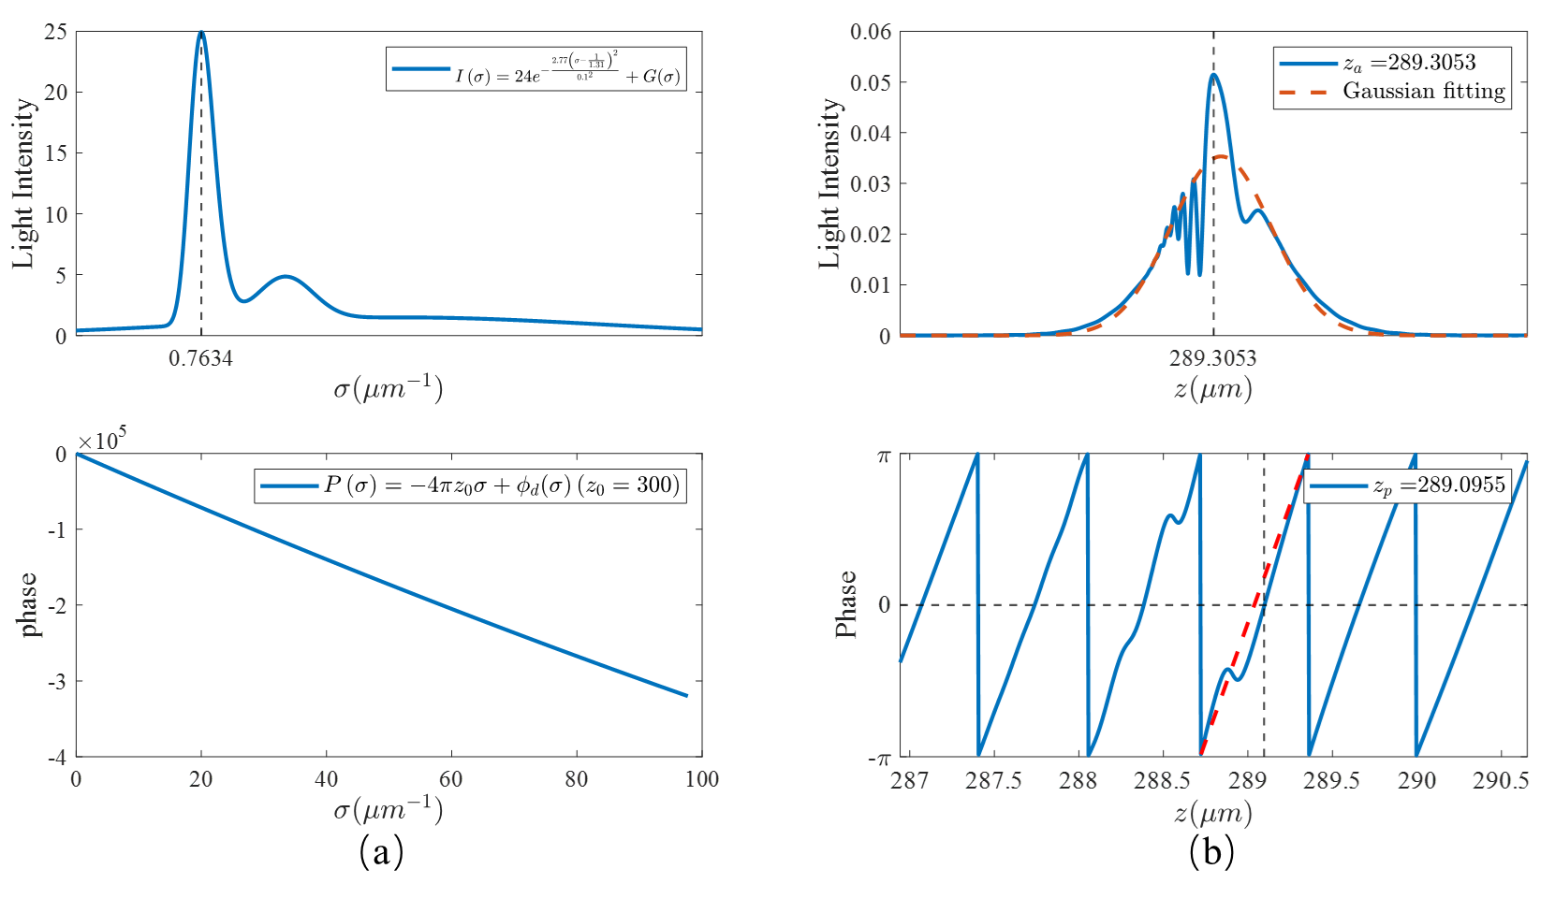

Fig. 7 (a)Amplitude() and phase() of. (b)IFT(Inverse Fourier Transform) of.

From the Fig.7(b), The peak position in the amplitude distribution of is, and the zero phase position nearest is. From equation 11, we can get



The period of the unwrapped phase distribution is T=0.635. Hence, ,(Thein the simulation is 1310 nm).

To summarize, in the case of , B(z) have a maximum value at and, the phase distribution is a nonlinear distribution.

--------------------------------------------------------------- check later

**(3) The simulation results in Fig.7 are follows.**

In the simulation, we can eliminate of noises by using linear square line.

If ,,, then



Since, is expressed as



The fitted phase is shown in Fig.8(a). The expression of the fitted phase function is given by



Amplitude and phase of the signal is shown in Fig.8(a). IFT(Inverse Fourier Transform) of the signal is shown in Fig.8(b).

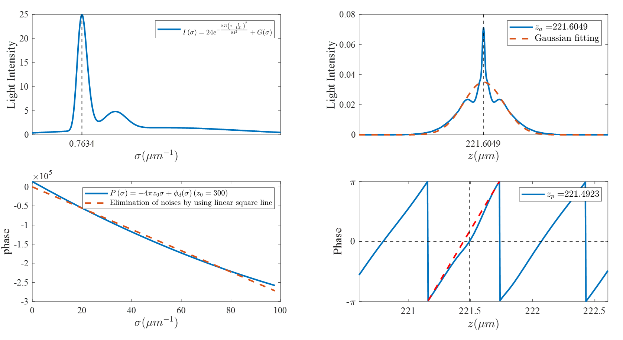

Fig. 8 (a)Amplitude() and phase() of. (b)IFT(Inverse Fourier Transform) of.

From the Fig.8(b), the peak position in the amplitude distribution of is, and the zero phase position nearest is. From Equation 11, we can get



Since, and. Then





In the Fig.8(b), we can get .

To summarize, in the fig.7, A(z) have a maximum value at.The phase distribution may be correct.

About centre wavelength.

